**CSE 3902**

**Sprint 5 Reflection**

**Group Loading…**

Group Members: Ben Roth, Sean Burns, Alex Quedens, Jiayi Pu, Diya Adengada

[Trello Board](https://trello.com/b/b2owSuhc/3902)

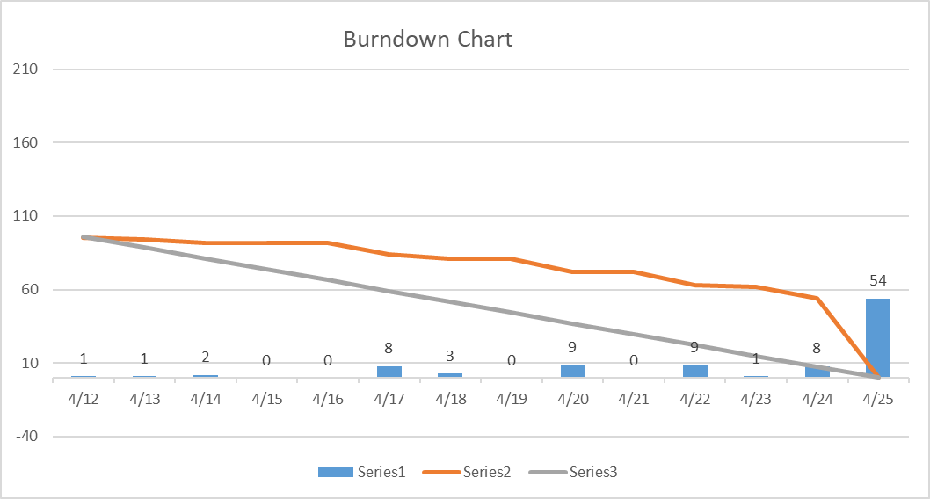

Overall, we as a group did decently well. It definitely seemed like we were a bit more scattered for this sprint when compared to past sprints in terms of how close we worked. Due to the nature of this sprint being a sort of “do whatever you want” sprint, we all worked on completely separate features that tied in very little with each other, causing us to not communicate as effectively as we had in the past. Also, due to us not being able to fully complete everything we needed to for the previous sprint, some development time and energy from this sprint had to be sacrificed in order to complete those missing portions. In addition to that, we also seemed to not really begin work on this sprint for a few days after it was assigned which may have resulted in us all being a bit burned out from the crunch time from the previous sprint. This caused us to have a late start to this sprint, further reducing our time sprint adding new features. We were unfortunately unable to dedicate any meaningful time to refactoring our code since we were mainly focused on functionality of the software, which resulted in us having several classes that were very long and could have been simplified more. If we had more time and less distractions with things like other classes, we would definitely be able to improve our code quality to much higher standards, but this is the final deadline for this project and we are happy with what we have added and what we have accomplished as a whole.